关于软件的安装问题
Regarding the installation issue of the software

1.扫描二维码可直接下载软件
Scan the QR code to directly download the software
2.在微信上接收的文件
1. Files received on wechat

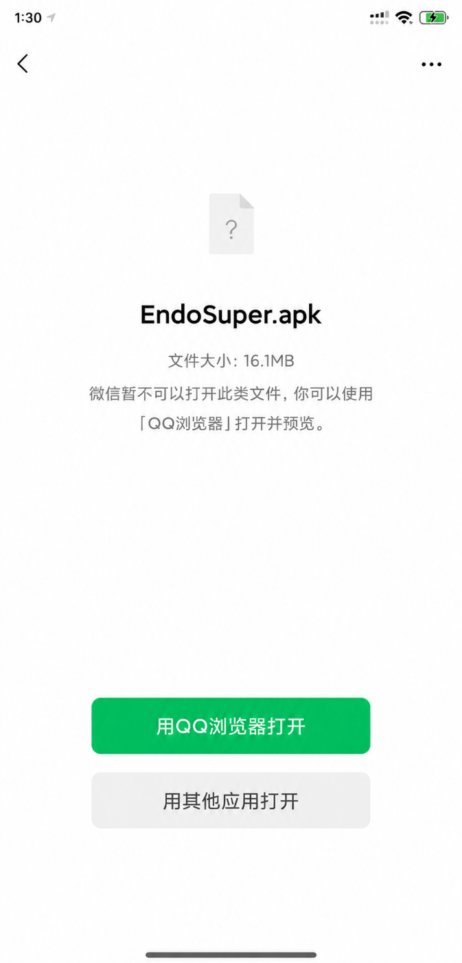

要用浏览器打开，这里用QQ浏览器举例，如果没有QQ浏览器，就按用其他应用打开，手机有自带浏览器，打开就可以进行安装。
To open with a browser, here with QQ browser example, if there is no QQ browser, press the use of other applications to open, the phone has its own browser, open can be installed.

3华为手机的纯净模式
Pure mode of Huawei mobile phone

在手机的主界面，我们点击【设置】，进入新的页面
In the main interface of the mobile phone, we click [Settings] to enter a new page
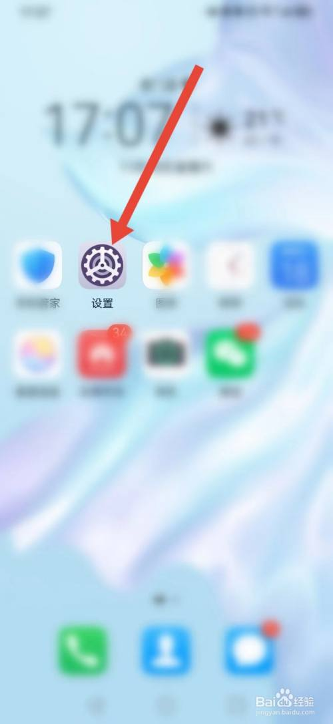

其次，我们点击【系统和更新】
Second, we click on "System and Update"
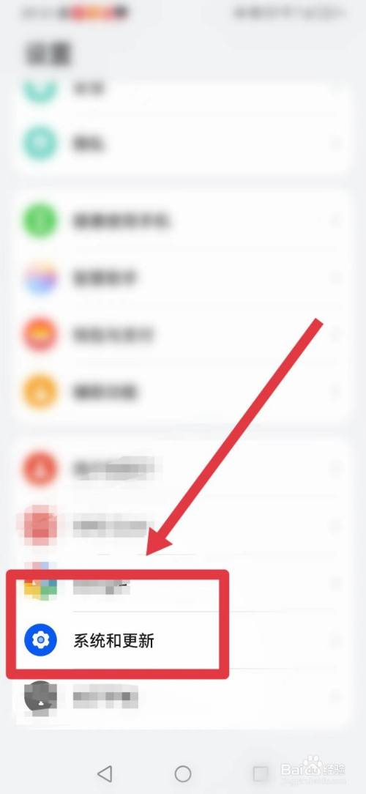

接着，我们点击【纯净模式】
Next, we click on Pure Mode.
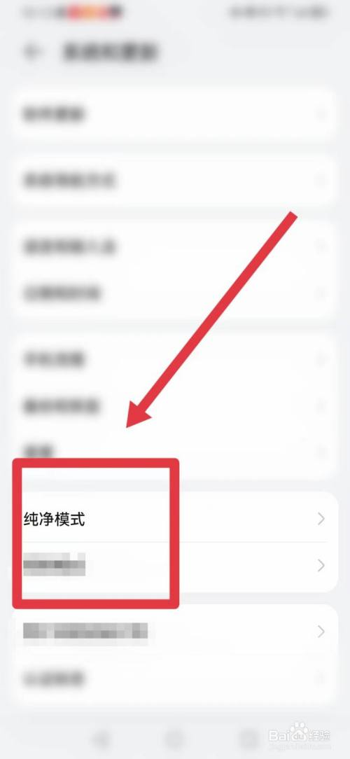
我们点击【增强防护】的按钮，就可以关闭纯净模式了
We can turn off Pure mode by clicking the "Enhanced Protection" button
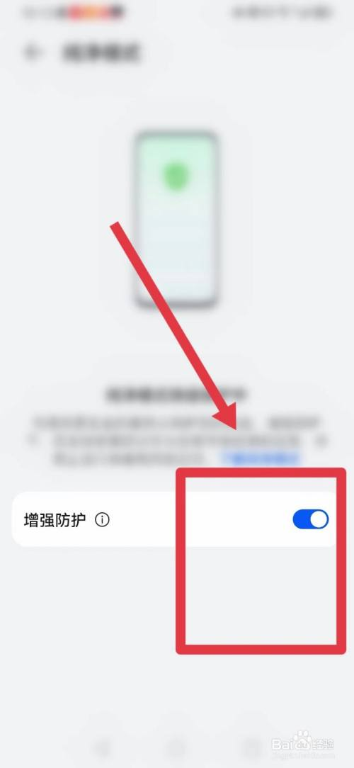

- 部分手机需要手动打开OTG选项
Some mobile phones require manual activation of the OTG option
首先打开设置
open the Settings
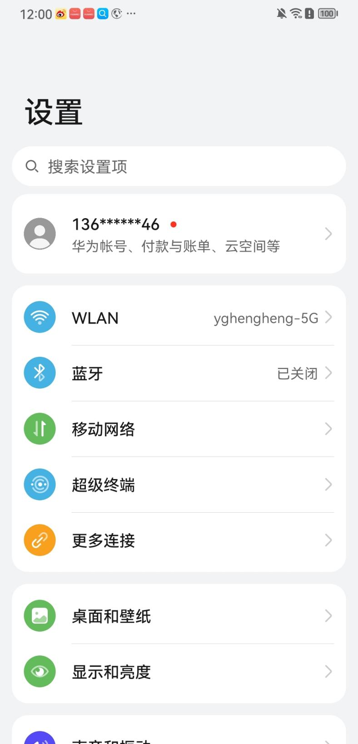
在这里搜索OTG把功能打开即可
Just search for "OTG" here and turn on the function

